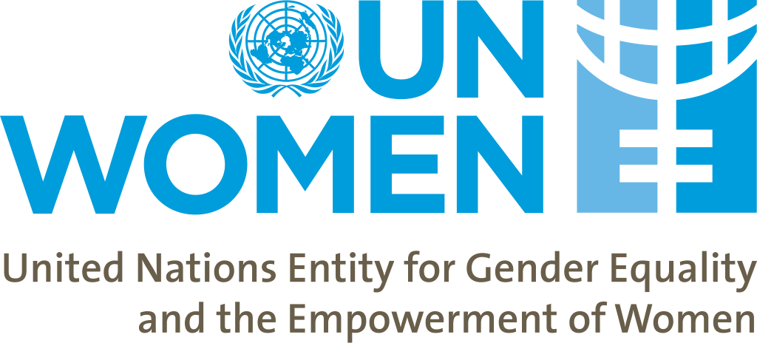

CALL FOR EXPRESSIONS OF INTEREST

for Civil Society Organizations (CSOs)
interested to participate in the capacity building programme on Gender Budget Watchdog reporting

UN Women Programme area: Gender Responsive Budgeting (GRB)

CSOs Profile: 1: Gender Equality
CSOs Profile 2: Local and Central Governance
CSOs Profile 3: Human Rights
CSOs Profile 4: Public Finance and Accountability

BACKGROUND

The United Nations Entity for Gender Equality and the Empowerment of Women (UN Women) in Moldova is launching a selection procedure targeting Civil Society Organizations (CSOs), working in the Republic of Moldova and with the aforementioned profiles, to build their capacity in preparation of Gender Budget Watchdog reports by exposing them to international practices on gender responsive budgeting.

UN Women, grounded in the vision of equality enshrined in the Charter of the United Nations, works for the elimination of discrimination against women and girls; the empowerment of women; and the achievement of equality between women and men as partners and beneficiaries of development, human rights, humanitarian action and peace and security. Placing women's rights at the center of all its efforts, the UN Women leads and coordinates the United Nations system efforts to ensure that commitments on gender equality and gender mainstreaming translate into action throughout the world.

Through its programmes and projects, UN Women is providing technical assistance to national partners (governmental and non-governmental) in the implementation of existing international and national commitments to women’s rights and gender equality, it facilitates networking and exchange of good practices and advocates for women’s rights and gender equality in all areas of life.

UN Women’s presence in the Republic of Moldova has evolved from being a project-based office in 2007 to a Country Office with fully delegated authority as of 2015. The work of UN Women in Moldova is guided by its new Country Strategic Note for 2018-2022, aligned with the Republic of Moldova–United Nations Partnership Framework for Sustainable Development 2018–2022, the Global Strategic Plan of UN Women for 2018-2021, the National Strategy on Gender Equality for 2017-2021 (NSGE), and aims to contribute to the gender-responsive implementation of the 2030 Agenda for Sustainable Development.

The newly approved UN Women Strategy for Moldova 2018-2022 focuses on three main areas: 1/strengthening women’s participation in politics and decision making, 2/economic empowerment of women and 3/ending violence against women and girls. Gender Responsive Budgeting (GRB) is integrated in the current Strategic Note for 2018-2022 under the “Women lead, participate and benefit equally from governance system” Outcome, and is meant to contribute to increased capacities of the public institutions to analyze and improve policies, regulations, and budgets to fulfill gender equality commitments.
The second National Strategy on Gender Equality (NSGE) for 2017-2021 and its associated Action Plan, approved in early 2017, focus on ten areas of interventions with one dedicated to GRB.
Under the GRB area of intervention, the NSGE will focus on development, piloting and institutionalizing of GRB tools (gender sensitive indicators, expenditure strategies and concepts) and building capacity of relevant public institutions and CSOs on gender equality, including support for development of ministries’ gender sensitive sectorial action plans and monitoring budgetary expenditure through the lens of its impact on women and men.

RATIONALE
UN Women places important focus on accountability and monitoring mechanisms for tracking performance on gender equality commitments. In Moldova, Civil Society Organizations (CSOs), including women's groups, networks and gender advocates still have insufficient capacity to adequately monitor budgetary expenditure through the lens of its impact on women and men. On the other hand, CSOs play an important role in keeping central and local governments accountable to gender equality commitments and their dialogue and advocacy efforts are crucial for inclusion of gender issues in policy and programme planning at national and local level.
In 2018 UN Women in Moldova will support implementation of the first training program on Gender Budget Watchdog Reporting for CSOs working in the Republic of Moldova and interested to develop their knowledge and skills to monitor the impact of public policies and public spending on women and men. The training program for CSOs on Gender Budget Watchdog Reporting will be structured in two modules and will include a 3-day Training on Gender Responsive Budgeting and Budget Monitoring and a 3-day Workshop on Gender Watchdog Reporting, to be organized in June and September 2018, to engage and support up to 15 CSOs in preparation of Gender Budget Watchdog reports by exposing them to best international practices.
The training program for CSOs on Gender Budget Watchdog Reporting will be tailored based on CSOs training needs and capacities, assessed by a team of international and local consultants responsible for development and delivery of the above training program. The consultants will provide post-training support to the previously trained CSOs to 1/analyze local budgets and develop gender budget watchdog reports and 2/organize local dialogue events to present the findings of the Gender Budget Watchdog Reports and advocate for their future use for gender sensitive budgeting and policy making in pilot municipalities and towns of Moldova. The pilot areas will be selected by the participating CSOs in close consultations with UN Women in Moldova.
UN Women will ensure the administrative and logistical arrangements for organization of this training program.
The trainings will be conducted in English. Translation in Romanian will be available.
The successful participants will be awarded certificates.
ELIGIBILITY

UN Women invites qualified and registered CSOs/NGOs, working in Moldova and implementing programmes and/or projects aimed to advance gender equality and women’s rights, good governance, accountability, transparency, participation, and inclusion; (b) share the UN Women’s vision and core values; (c) have on-going programmes/ projects which are either fully or partially funded from other sources; and (d) are willing to enter into partnerships with UN Women in Moldova and contribute to strengthening the role and engagement of CSOs, including women’s networks and organizations from less developed areas in Moldova, to influence local policies and advocate for more transparent and gender responsive policy and budget making processes.

This Call for Expression of Interest is not for sub-contracting of services, nor is it for consultancy services.

HOW TO APPLY

Organizations that wish to respond to this Call for Expression of Interest are requested to send their Motivation Letter and dully filled in Expression of Interest template by e-mail, marked “Capacity Building Programme for CSOs on Gender Budget Watchdog Reporting”, to irina.cozma@unwomen.org by 14th of May 2018.

The Motivation letter and the dully filled in Expression of Interest template (Annex I) must be submitted in Romanian or English language, along with a copy of CSO’s registration certificate in Moldova and copies of the latest Annual activity and financial report, if available, as separate email attachments.

Annex I. EXPRESSION OF INTEREST TEMPLATE

 | KEY AREAS | BRIEF DESCRIPTION
1 | CSO information | Name:  Address:
2 | CSO expertise and experience in four profile areas | - Gender Equality:  - Central and Local Governance:  - Human Rights:  - Public Finance and Accountability:
3 | Governance structure and management capacity of the CSO | Total staffing:  Staff by area of expertise:
4 | Experience in building capacities of communities and local governance structures | Examples of effective engaging with local or central government structures:  Examples of effective engagement with local communities:
5 | Work experience with UN agencies | Name of the project or programme:  Timeframe:  CSO’s role and responsibilities:  CSO’s main deliverables:  Total budget:
6 | Other relevant information

